
DATE: 16.12.2020

MUSIC PROPOSAL

Carolina & Domenic’s Wedding | 11 December 2021
Venue: Boschendal Olive Press



Prepared for:
Amy York
Amy York Events
amy@amyyorkevents..co.za
082 366 8008

bookings@tonesofnote.com

www.tonesofnote.com

+27 72 510 4859

ABOUT US

For 20 years, Tones of Note has been satisfying clients with a love for music - clients who recognise the essential part music plays in creating an extraordinary experience. The agency of choice for some of the world’s finest event producers, from Colin Cowie to Anne Mann, we offer an exceptional service, going to great lengths to translate a client’s dream into musical reality.
We love what we do. This translates into the incredible care and attention to detail we give each event. Working with the finest local and international performers, our bands and musicians perform with passion and energy every time they take the stage. Guaranteeing flawless execution regardless of style and genre, we offer incredible versatility and professionalism for all occasions, settings and tastes.
It is our greatest joy to work with clients in curating and producing a distinctive entertainment offering. Making music while taking care of business, you can be assured of a structured process which guides you in your musical decision making, bringing your personal taste to the

fore and ensuring your event reflects who you are.

Please click on the image above to go through to the video reference.
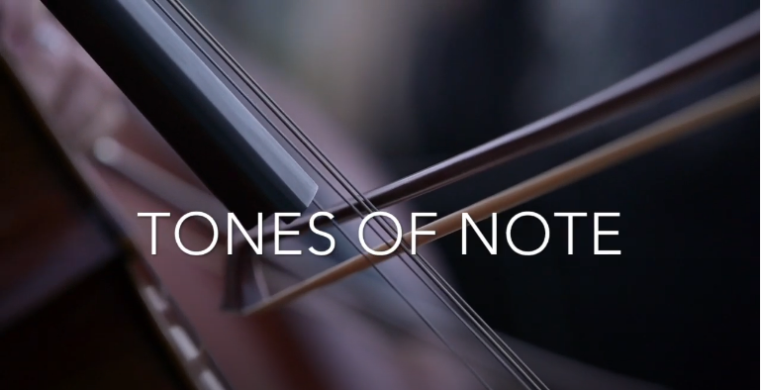

www.tonesofnote.com

+27 72 510 4859

bookings@tonesofnote.com

Your wedding is an intimate reflection of you and as such requires musical and creative attention. To authentically convey that feeling to the guests sharing in this momentous day, your musical input is invaluable.
Over the next year, we’ll be working with you on your wedding soundtrack. Building on our experience of what works and what doesn’t, we’ll guide in the repertoire selection process from closing guest arrivals to closing song.
Most of the suggestion acts below are open to learning new repertoire, so if you’ve got something specific in mind, let us know. While we’ll try out best to accommodate your vision, we’ll also be honest when we feel something won’t work musically or is not possible.

PROJECT BRIEF

The ceremony marks the bringing together of you and your families and as such should incorporate your backgrounds and represent you as a couple. With that in mind, we’ve put forward a few options for to choose from. All of the acts below are able to play a 15-20-minute set to welcome guests into the ceremony area.

CEREMONY

Solo guitar + vocals:
Reinterpreting a range of songs from Drake’s Hot Line Bling to Alicia Key’s If I Ain’t Got You, Ethan Florus is known for his smooth vocals and deft guitar playing. He developed his vocal and guitar skills during the 5 years he spent at the Stellenbosch University Konservatorium. He drives his passion for the art by sharing his skills through teaching, and his music through performing and recording.

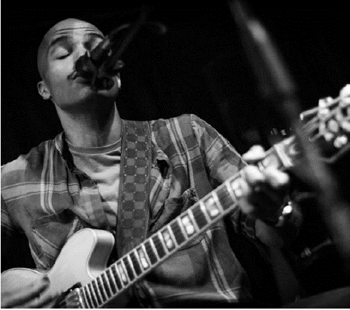
Please click on the image above to go through to the video reference.

Another great option to consider for the ceremony is solo guitar player
and vocalist Lize Mynhardt. Lize Mynhardt is a gifted, driven, and influential musician, spending the
last decade writing and releasing her own songs. Born in Cape Town,
South Africa, Lize was blessed with perfect pitch and has mastered
seven instruments excluding her voice, making her a unique artist.
She has released 9 songs, a Christmas album in aid of Pebbles Project
charity, and has collaborated with a diverse group of other artists
including DJ Cosher, Howard Edward, DSB, DJ Qness, Ben Ludik and
producers from Nashville.

ARTIST SELECTION

Solo guitar + vocals continued:
Another great option to consider for the ceremony is solo guitar player and vocalist Lize Mynhardt.
Lize Mynhardt is a gifted, driven, and influential musician, spending the last decade writing and releasing her own songs. Born in Cape Town, South Africa, Lize was blessed with perfect pitch and has mastered seven instruments excluding her voice, making her a unique artist. She has released 9 songs, a Christmas album in aid of Pebbles Project charity, and has collaborated with a diverse group of other artists including DJ Cosher, Howard Edward, DSB, DJ Qness, Ben Ludik and producers from Nashville.
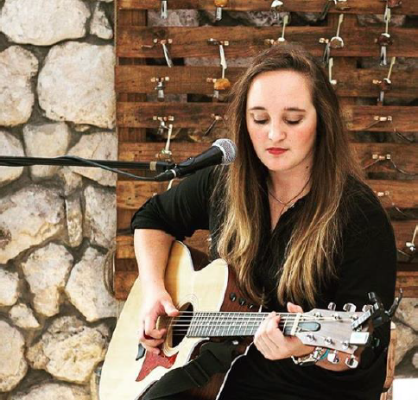
Please click on the image above to go through to the video reference.
www.tonesofnote.com

+27 72 510 4859

bookings@tonesofnote.com

African Choir:
Given that some of your guests will be joining us from overseas, the use of an African choir is a beautiful way to welcome them to South Africa.
The Asili Vocal Ensemble was created by a group of friends who share the joy of making music together. Rooted in choral singing, they have a fusion of classical, opera, pop and jazz in their sound. Their mission is to create magical, music moments that warm the hearts of their audiences.

Ranging from a 5-piece to a 10-piece, the Asili Vocal Ensemble can perform a cappella or with an accompaniment.

Continued below.

Please click on the image above to go through to the video reference.

www.tonesofnote.com

bookings@tonesofnote.com

+27 72 510 4859

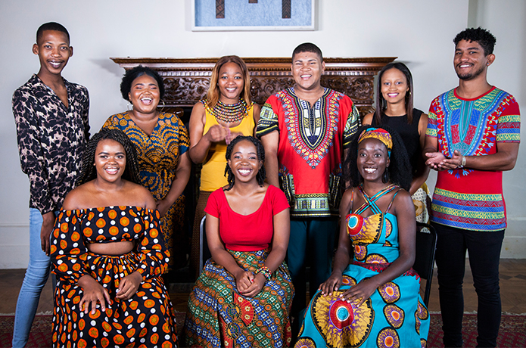
Please click on the image for the video reference
African Medley – Asili Vocal Ensemble – Please excuse the quality of this video, it was taken on a guest’s phone.

String quartet:
If you’re looking to go in a more traditional direction, we’d recommend using a string quartet. The string quartet we regularly use features 2 x violins, 1 x viola and 1 x cello and has a large repertoire range from contemporary to classical pieces.
String quartet - Coldplay - Fix You
Depending on budget, we can also combine some of the options above – for instance, we’ve used 5 members of Asili and combined them with the string quartet to perform well known songs including Stand By Me, At Last and Your Song.

Leading the guests from the ceremony area to the pre-drinks, we spoke about using African drummers. These drummers would then join a marimba band positioned at the pre-drinks area on the lawn.

TRANSITION

www.tonesofnote.com

bookings@tonesofnote.com

+27 72 510 4859

As guests arrive in the pre-drinks area, they’ll be greeted by a Il Afro Suns Marimba band to which the percussionists who lead the procession will join. We suggest that the marimba band plays for 30-40-minutes after which Rus Nerwich will start DJing performing an Afro-electronic feature, livening up the tempo for the remainder of the event.
Rus Nerwich – DJ
Hailing from Cape Town, saxophonist, composer, producer and DJ Rus Nerwich has established himself as one of South Africa’s most creative and prolific recording and performing artists. Crossing genres from jazz and funk to world music and neo-soul, Rus' style is diverse, engaging and constantly evolving.
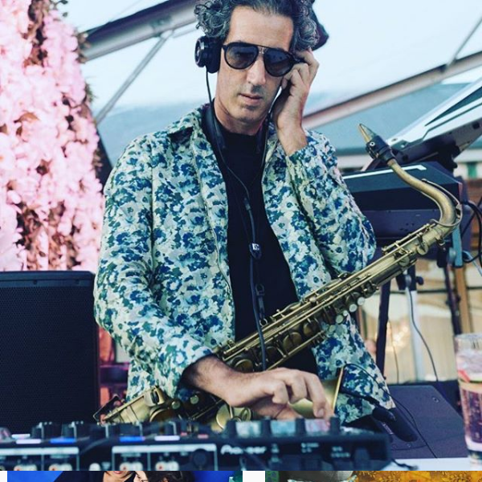
Please click on the image for the video reference.

Please click on the image for the video reference.

https://www.youtube.com/watch?v=AOY6eff1cj8

PRE-DRINKS

DINNER
As the dinner and dance area are revealed, guests are greeted by Francesca Biancoli and a 4-piece jazz quartet. Over the course of dinner, Francesca and Nathan will take the stage performing a range of Bossa Nova and Crooner style songs.

Continued below.

https://www.youtube.com/watch?v=AOY6eff1cj8

bookings@tonesofnote.com

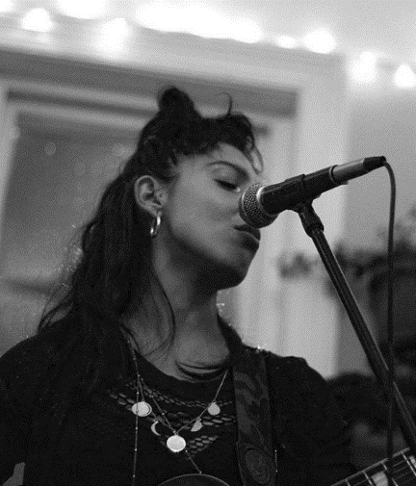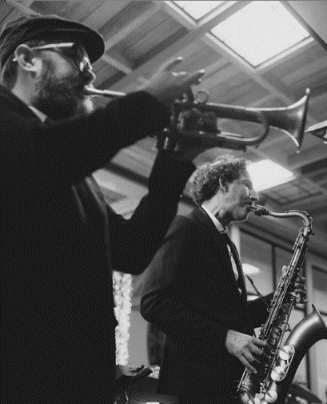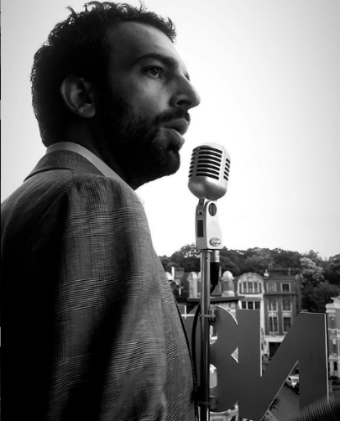
Please click on the images for the video reference.

N8N - DJ + Live Accompaniment
N8N - Mixcloud

www.tonesofnote.com

+27 72 510 4859

DANCE
Directly following your first dance, the band featuring Nathan Ambach and Francesca Biancoli on vocals, accompanied by saxophone, keys or guitar, bass and drums to perform high-energy dance set including some Latin songs.
Touring and performing together for the last 6 years, Rus Nerwich and Nathan Ambach (N8N) have developed an electric onstage chemistry, offering clients an all-inclusive musical solution.
Both Nathan and Rus bring together 20 years of musical and performance experience. From world-class live performances of quintessential classics covering soul, funk, blues, pop and jazz to a dance till you can’t dance no more DJ set, you are guaranteed one of the greatest parties of your life!

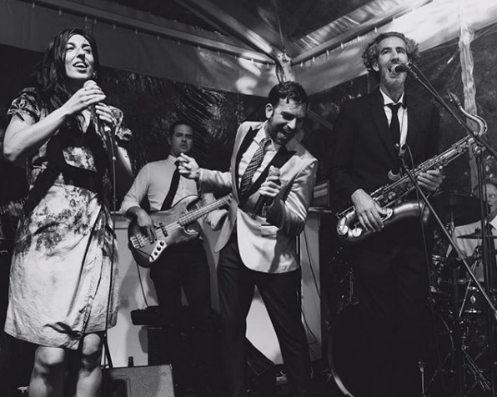
Please click on the image for the video reference.

https://www.youtube.com/watch?v=AOY6eff1cj8

bookings@tonesofnote.com

www.tonesofnote.com

+27 72 510 4859

PARTY
In 2006, in his hometown of Antwerp, Nathan launched the nightlife series: The Love Below as ‘Your Monthly Rendezvous with Soul’, where he is still the resident DJ + promoter of funky music worldwide!
He’s DJ’d alongside Mark Ronson at the WMC in Miami and played at the Love Below with DJ Jazzy Jeff (The Fresh Prince), DJ Premier, DJ Maseo (De La Soul), and DJ Rashida – the official tour DJ of Prince and Bruno Mars and DJ'd sets in clubs and events around Europe, America, Asia, Africa and the Middle East.
His Spotify playlists and online mixtapes represent his funky style, championing soulful music with great grooves and party hooks. For over 20 years, N8N has been rocking the business from BBQs to Bar-Mitzvahs!
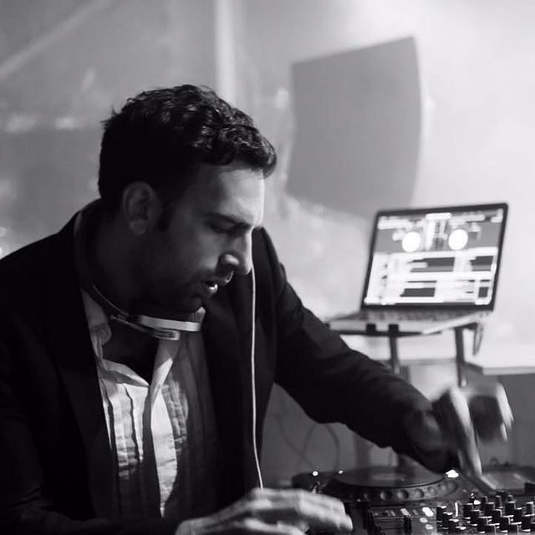
Please click on the image for the video reference.
N8N - DJ + Live Accompaniment
N8N - Mixcloud

